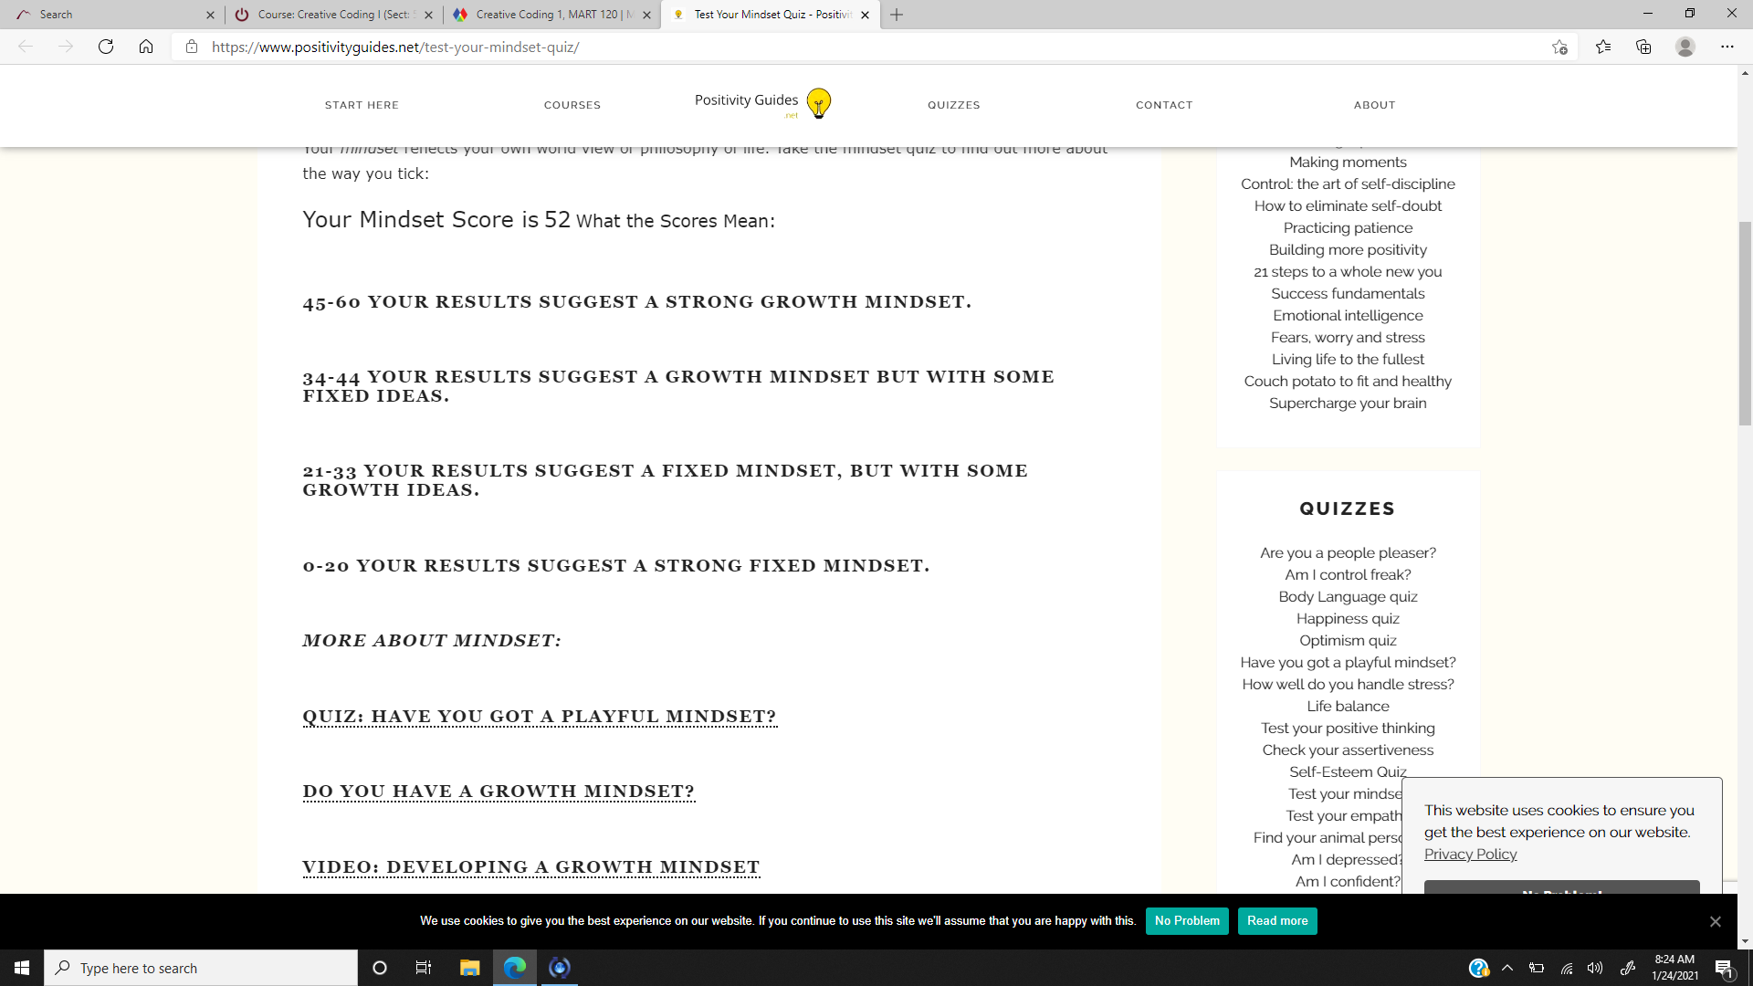
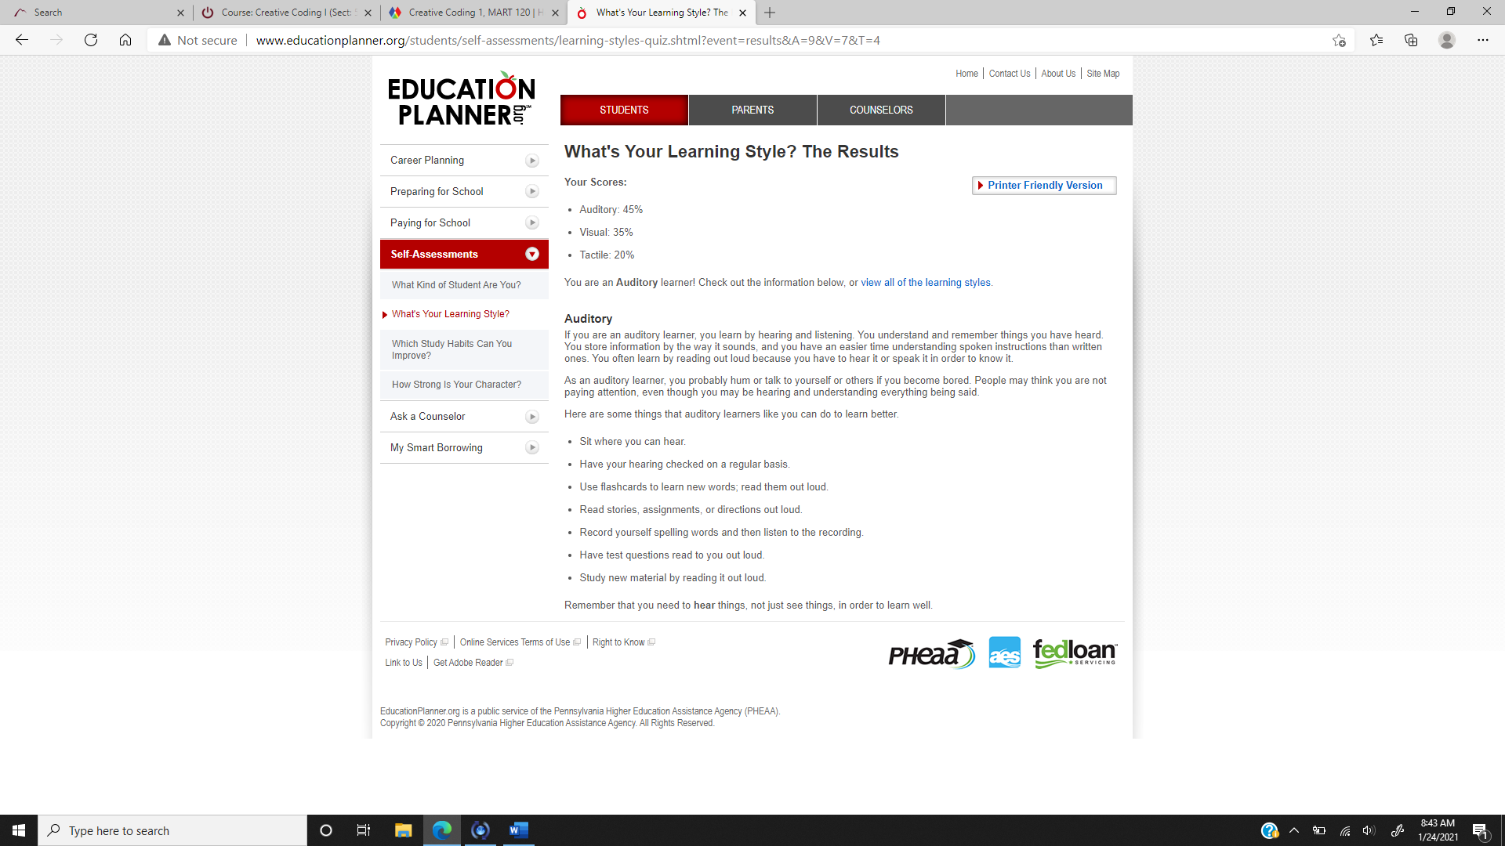
https://studio.code.org/projects/dance/4b93v67EvzOVp3vDTQVq7YGJdQFpc8I03pe6--HiWZU
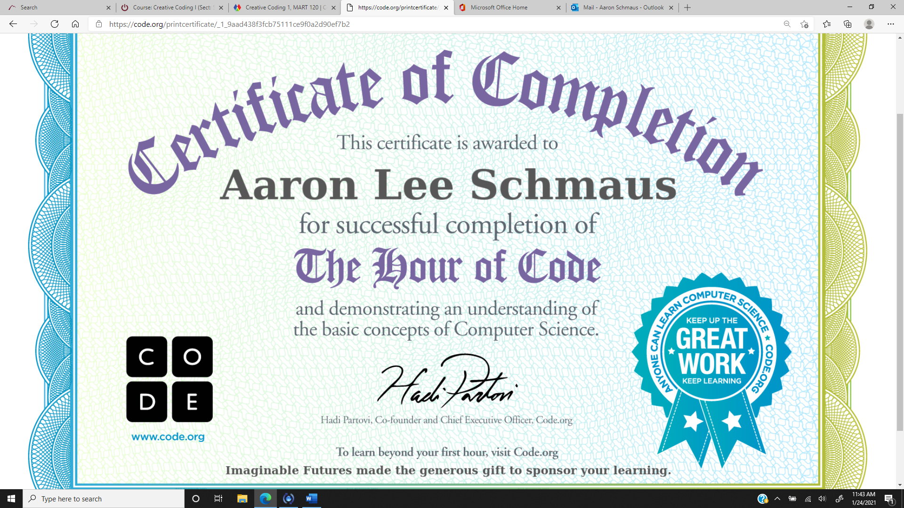

Last Lecture
As I stated in our group discussion as it pertains to mindset, this lecturer reminds me of my father. He never let anything stop him from achieving his goals. From Capitan Kurk to flying weightless, he found a way to make his dreams happen. This story resonates so much with me because of my father. I was always taught to continue to find a way to make your dreams happen.
My life was always filled with ups and downs. Though my skin is white, I am half Mexican and until 12 years old, had a Hispanic last name. I saw racism and was put into segregated schools my first couple of years in school until we moved to Montana. From the moment we moved to Montana, everything changed for me. Instantly, I was approached with a new mindset of mental toughness and perseverance. I joined some new friends at their wrestling practice and it was made apparent to the coaches that I had raw talent while rolling around on the mat, goofing off with friends. They offered me a place on the team the first day and the first season, I went to the State wrestling tournament and Regionals.
It wasn’t until later in life that I realized the messages that my late father was trying to teach me but, I seemed to naturally grasp what my coaches were saying. Continue to work and you will continue to be successful. Everyone loses in one way or another, but it is through those losses that we gain the knowledge and experience to keep driving and learn how to not make the same mistakes. We can make our dreams happen, but you have to believe that you can. I was not the best wrestler on the mat but I always had an attitude that I felt like I would win, no matter who I faced. My coach John O’Dell, gave me the best compliment that I could ever receive one day when I came home to visit years after I had graduated high school.
I didn’t tell him that I was coming home, or even that I was coming to visit wrestling practice. Maybe it was nostalgia but I just wanted to be around that atmosphere and mentality. When I walked in, he gave me a hug, shook my hand and stopped practice. Everyone circled up and O’Dell said “Do you remember the story I told you about the most arrogant son of a bitch I ever coached? This is him! That sounds bad but it is not! No matter who he wrestled, whether he was going to win or not, he knew he would win! He never beat himself!”
Being called arrogant is not usually a good word but the rest of the short speech was true and I later thought about the meaning. You can’t beat yourself. Your number one fan has to be you. If you believe that you are going to be beat, then you have already lost. We can accomplish much more than we think just by believing in ourselves.

Mindset
According to leading psychologists, most of your base thought processes are developed by the age of twelve years old. If this is true, as I suspect them to be, I have been engulfed in a growth mindset from a very young age. Although he was very unconventional, my father dealt heroin in the Vietnam war. Many would frown on this and I am not particularly proud of this point, but it taught him to never give up. He would find new and unique ways to transport his products to other countries and to always think on his feet. He once told me a story about him transporting a small amount of his product into China in a secret compartment in the heal of his boot. While one customs agent was frisking him, another was checking his boots. He thought the agent would find his secret compartment so he yelled "Hey, I was born with that! It is a carry on! You don't need to touch people that way!" in Chinese to the agent frisking him. The agents were so embarrassed that they discontinued the search and let him go.

Of course, I am not advocating that people become drug smugglers. I am saying that this sort of "out of the box" thinking and problem solving was what developed my mind. I was always taught that I can do nearly anything and that I just needed to find a way to do it. My father was a people person, a salesman and a chameleon. I am more of an introvert but one of the biggest lessons that I learned from him was that I needed to study the psychology of people, their mannerisms and body language and never stop studying the different ways to make things work. Because of this I have accomplished so much. Anyone can accomplish, nearly anything, we just have to find a way to make it happen.
I have a growth mindset, according to the quiz that we were given. I would have to agree with this assessment. I do not let anything diminish my goals. I simply try and think about a different way to achieve them.

